DriverPass System Design Document
CS 255 — Systems Analysis and Design
Kristina Pagan
Southern New Hampshire University
October 2026

1. Introduction
This system design document translates the DriverPass business requirements into a proposed system structure. The design uses a blended approach: activity and sequence diagrams describe how important tasks move through the system, while the class diagram describes the information the system must store and how the information is related. The diagrams are design-level models intended to guide developers and support review with DriverPass stakeholders.

2. System Overview and Design Goals
DriverPass will be a web-based, preferably cloud-hosted system for customer registration, package selection, driving-lesson reservations, online learning and practice tests, employee administration, reporting, and receipt of DMV updates. Customers and employees will use the same system through role-appropriate screens. The design must support access from computers and mobile devices while requiring an internet connection to change central records.
- Make it convenient for customers to register, choose a package, and manage lesson reservations.
- Help the secretary schedule appointments for customers who call or visit the office.
- Associate every driving lesson with the correct customer, driver, vehicle, date, and two-hour time slot.
- Provide online classes and practice tests to customers whose package includes them.
- Give management useful reports and a traceable history of important changes.
- Protect customer information through role-based access and secure handling of payments.
- Keep practice content current through a supported DMV update process.

3. Actors and Use Cases
The primary actors are Customer/Student, Secretary, Driver/Trainer, Owner/Manager, IT Officer, and the external DMV service. A payment provider is assumed for secure payment processing; it is shown in the class model as a provider reference rather than as an internal DriverPass payment engine.
The use case diagram captures account registration and access, package selection, appointment scheduling and changes, online learning and testing, customer and driver administration, package management, reporting, audit tracking, account access management, and receipt of DMV updates.
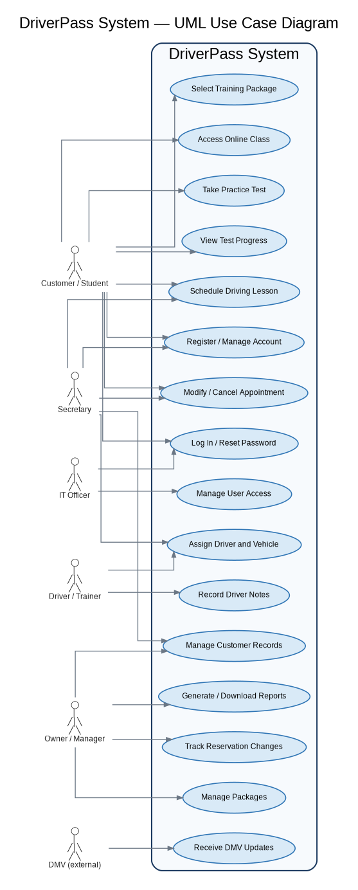
Figure 1. DriverPass use case diagram.

4. Activity Diagrams

4.1 Schedule a Driving Lesson
This workflow begins when a customer or secretary requests a lesson. The system checks that the customer has an active package and that both a driver and vehicle are available for the requested two-hour period. If there is a conflict, the user selects another time. If the slot is available, the reservation is saved, an audit entry records who created it, and the user receives confirmation. This workflow supports accurate scheduling and reduces double-booking.
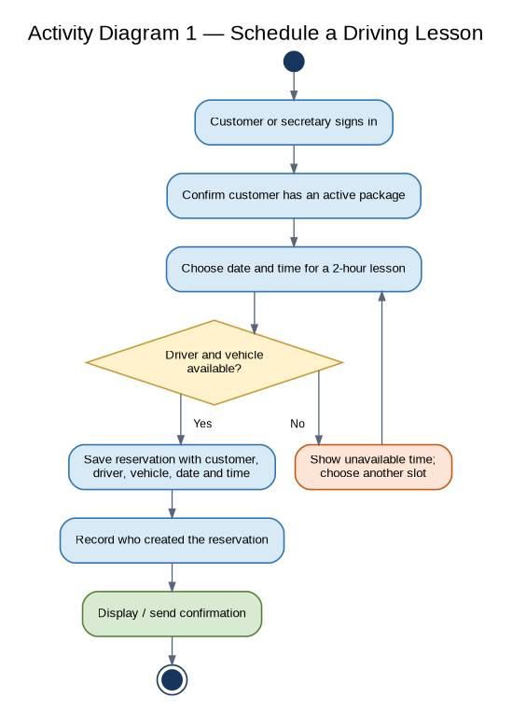
Figure 2. Activity diagram for scheduling a driving lesson.

4.2 Complete an Online Practice Test
This workflow checks whether the student's training package includes online access before allowing a test to begin. The student selects a test, submits answers, and the system records the test name, score, time taken, and status. Results are then displayed in the student's progress area. This process reflects the requirement to make online course materials and practice tests available only to eligible package holders.
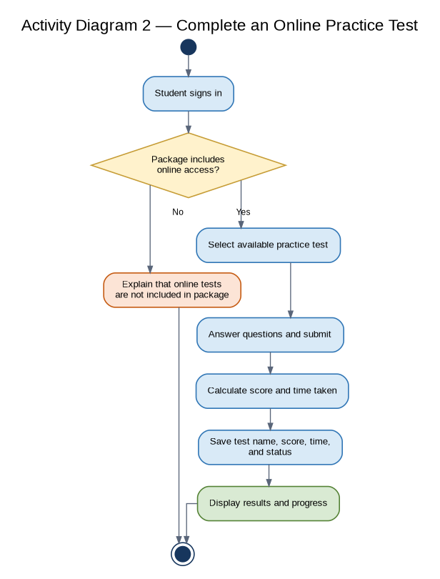
Figure 3. Activity diagram for completing an online practice test.

5. Sequence Diagram
The sequence diagram details the messages exchanged when a customer schedules a lesson. The web interface sends the request to the reservation service, which checks availability against existing reservations. When a slot is available, the reservation is saved and the action is recorded in the audit log. The interface then displays confirmation. If the slot is unavailable, the interface presents alternatives rather than saving a conflicting reservation.
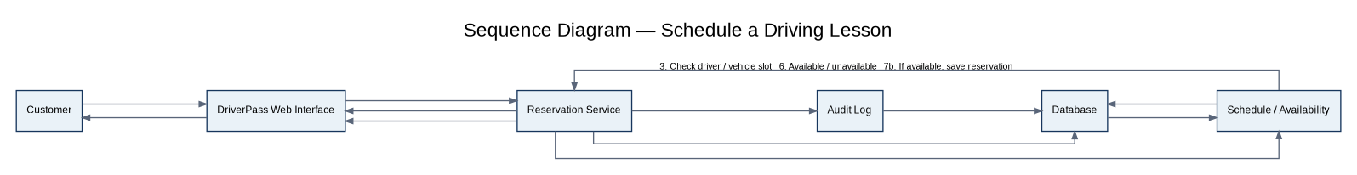
Figure 4. Sequence diagram for scheduling a driving lesson.

6. Class Diagram and Core Data
The class diagram identifies the main data groups needed for the first release. Customer and Employee records connect to user accounts; customers select training packages and can have multiple reservations, payments, and test results. Each reservation is associated with one driver and one vehicle. Audit events record who performed important actions and when. Passwords are represented as password hashes rather than plain text, and payment records store a provider reference rather than raw card security data.
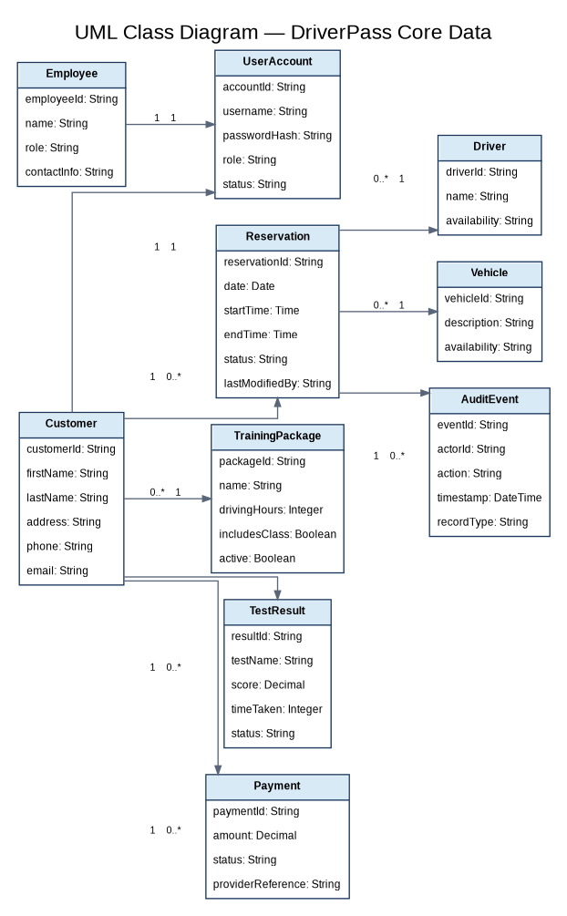
Figure 5. UML class diagram showing core classes and relationships.

7. Technical Requirements

7.1 Hardware
- Customer and employee devices: desktop or laptop computers, tablets, or smartphones with a supported modern web browser and internet connection.
- Hosting environment: cloud-hosted application and database services with redundant storage and managed backup capability.
- Office equipment: internet connectivity and standard printers for staff who need to print activity reports.

7.2 Software and Tools
- A responsive web application that works on common desktop and mobile browsers.
- A relational database to store customers, accounts, packages, reservations, drivers, vehicles, test results, payments, and audit events.
- A secure authentication and authorization component supporting account recovery, role-based permissions, and account blocking.
- An established third-party payment provider; DriverPass should not build its own card-processing service.
- A supported integration or import/notification mechanism for DMV rules, policies, and sample-question updates.
- Reporting and export capability for printable reports and spreadsheet-friendly downloads such as CSV or Excel-compatible files.
- A modeling/design tool such as Lucidchart for maintaining UML diagrams and design documentation.

7.3 Infrastructure and Data Management
- Use HTTPS/TLS for data exchanged between browsers and the hosted system.
- Use managed cloud backups and a documented restoration process.
- Require users to be online to create or modify central records; allow offline use of downloaded reports only.
- Validate reservations centrally and prevent overlapping reservations for the same driver or vehicle.
- Record reservation creation, modification, and cancellation with the acting user, timestamp, action, and affected record.
- Keep test content and packages configurable so future developers can update DMV materials and add future capabilities without redesigning the entire system.

8. Functional Requirements Mapped to the Design
Requirement area | How the design supports it
Accounts and roles | UserAccount, Customer, and Employee classes; login, reset, and access-management use cases.
Reservations | Activity and sequence diagrams validate availability, save the two-hour reservation, and log changes.
Drivers and vehicles | Driver, Vehicle, and Reservation classes preserve assignment relationships and reduce scheduling conflicts.
Online training | Practice-test activity diagram records score, time taken, test name, and status.
Management oversight | AuditEvent and reporting use cases provide traceability and downloadable activity information.
DMV updates | External DMV actor and update use case represent receipt and notification of updated content.
Payments | Payment class stores transaction status and provider reference; a third-party provider handles card processing.

9. Nonfunctional Requirements
- Performance: account views, availability checks, reservations, and practice tests should respond promptly while supporting multiple concurrent users.
- Accuracy: lesson durations, assignments, test results, and audit details must be stored consistently; conflicting driver or vehicle reservations must be rejected.
- Security: apply role-based permissions, secure authentication, protected data transmission, managed backups, and least-privilege access.
- Usability: use clear, responsive screens for customers and separate role-appropriate employee functions.
- Availability and recovery: cloud hosting should include backup and restoration arrangements that reduce DriverPass's day-to-day infrastructure burden.
- Adaptability: authorized staff can disable existing packages; more extensive package or module changes remain developer-supported in the initial release.

10. Assumptions and Limitations
The design assumes DriverPass will use a supported payment provider and that the DMV will provide a supported method for sending updates. The initial system supports disabling existing packages but does not let nondevelopers create or remove software modules. Central records cannot be changed offline; users may download reports for offline work. Availability and timing of DMV data depend on the external service, and payment processing depends on the selected provider. Additional features outside the interview requirements will require further analysis.

11. Design Notes for Development
- Confirm the final payment vendor and its integration requirements before implementation.
- Confirm the DMV data exchange method and whether updates arrive automatically or require an authorized review/import step.
- Define exact permissions for each employee role and document which actions create audit events.
- Confirm reservation conflict rules, including the handling of canceled lessons and time-zone display.
- Review the diagrams with DriverPass before implementation and revise them if the client changes requirements.

12. Conclusion
The blended design uses process models to explain the sequence of key work and an object model to define the information that supports it. Together, the diagrams and technical requirements provide a practical starting point for implementation while remaining connected to the needs recorded in the DriverPass business requirements document.

